PAPER PREPARATION GUIDE AND TEMPLATE FOR ENERGISE 2020
The names and affiliations SHOULD NOT be included in the draft submitted for review
Author Name¹, Author Name² ,Author Name³
¹Dept. name of the organization (of Affiliation)  Name of organization (of Affiliation)  City, Country  email address | ²Dept. name of the organization (of Affiliation)  Name of organization (of Affiliation)  City, Country  email address | ³Dept. name of the organization (of Affiliation)  Name of organization (of Affiliation)  City, Country  email address
ABSTRACT
The abstract should not exceed 250 words. It should be a brief and concise description of your paper, and should clearly identify and capture the unique features of your study.
Keywords—component, formatting, style, styling, insert (keywords)

INTRODUCTION

This document provides guidance towards formatting requirements for paper submissions to the Energise 2020 concalve. It is a template and we recommend that you directly compose your paper on this.
(This template, modified in MS Word and saved as a “Word Document”, provides authors with most of the formatting specifications needed for preparing electronic versions of their papers.)
To proceed:
1. Rename this document using the following format: letter “p” followed by the three-digit paper ID. For example: p111.
2. Replace the title "Paper preparation guide and template for Energise 2020” with your own title. Leave a placeholder for the names of the authors. Please do not provide any information about authors and affiliated organisations at this stage of the paper submission.
3. Compose the paper in this template. Make sure you use Normal style (10 font size, Times New Roman). Alignment should be justified.
OVERALL FORMATTING
1. The page size for your paper should be A4 size with an overall margin of 2.5 cm on all sides of the paper (top, bottom, right and left).
2. After the title and abstract section, the rest of the document is in a two-column format.
3. LEVEL 1 heading should be 12-font size, UPPERCASE and underlined, with 12-point spacing above and 6-point spacing below. The Headings Of The Subsection or Level 2 Headings are 10- font size, bold with each word capitalized, and have a 6-point and 3-point spacing after and before respectively. Level 3 headings: if needed, should be 10- font size, bold and sentence case (initial capital and then lower case); they end with a period.
4. Bullets and numbers should be left-aligned with the text, with a hanging indent of 0.5 cm, and a 3-point spacing above and below.
5. Each column should be 7.6 cm wide with a space between the two columns of 0.8 cm. The space between the columns should be centred on the paper.
6. The paper length should not be more than 8 pages for tracks- Urban & Utilities and Buildings & Communities. For Track-Energy Efficiency for Business Competitiveness shorter papers of 4 pages are also an option. Please DO NOT include page numbers.
Line and Paragraph Spacing
The text should be 1.15 line spacing. The “before paragraph” spacing between paragraphs should be 3-point, and 6-point spacing for “after paragraph”. Do not indent the first line of each new paragraph.
SPECIFIC ELEMENTS
Title, Authors, and Authors’ Affiliations
1. Titles should be in 14- font size, bold and capitalised. Do not use more than 2 lines for the title, and try to limit it to ten words.
2. Author name should be in 11- font size*.
3. Authors’ affiliations and name of the organisation should be in 9- font size and italic style*.
4. City, Country and E-mail address should be in 9- font size and sentence case*.

*These instructions are not valid for blind review process for full paper submission.
Sections
The main body of the paper should discuss (but not limited to) the following indicative sections:
• Introduction
• Methodology
• Discussion and result analysis
• Conclusion
• References
Other sections (Optional): Add the following sections if applicable:
Other sections as needed, in order to meaningfully organise the paper, may be added as per the authors’ discretion.
The sections and subsections should not be numbered.
References
We request you to follow the Harvard style of referencing for in-text citation (Yu et al., 2017) & reference list.
Number footnotes separately in superscripts. Place the actual footnote at the bottom of the column in which it was cited. Do not put footnotes in the abstract or reference list.
Figures and Tables
Figures and Tables can be included in the text. Both must have a number and a caption. The caption should be in font size 9 font size, bold and in Times New Roman font in Italics. Figure 1 is an example of a graph in the text with a caption below the figure. Please include a blank line above the figure and below the caption.
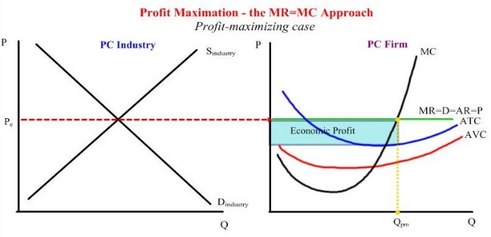
Figure 1: Figure Caption
Table 1 shows an example of a table, where the caption should be at the top of the table.
Heading 1 | Heading 2 | Heading 3
Entry 1 | Entry 2 | Entry 3
Table 1:Table Caption
Larger figures and tables may be included in the text. However, they should be arranged in the layout properly so that they appear at the top or the bottom of the page, or preferably on a separate page.
Equations
Each significant equation or formula should be displayed on a separate line. Centre equations and place consecutive equation numbers flush right in parentheses. For example:
a² + b² = c² | (1)
Mathematical symbols should be clear to avoid ambiguities. A brief description of the symbols used in your paper should then be added in a nomenclature section at the end of the text.
SUBMISSION INSTRUCTION
- To enable the blind review process please do not include your name and affiliation on the draft submitted for review.
2. Please submit your entire document in both MS Word and PDF format. Other formats will NOT be accepted.
3. The filename must follow the following rules: pXXX where: XXX is the 3-digit submission ID.
4. Files larger than 5MB should be compressed
5. If the paper does not met the submission requirements, it will not be possible to review it and you will be requested to resubmit. You will get a confirmation email once the paper is under review.

CONCLUSION
This paper provides guidance for submitting your paper to Energise 2020. Good luck and we hope to see you soon at the event!
NOMENCLATURE
a = first variable
b = second variable
c = third variable
If you have some nomenclature in your paper, then please add it here after the Conclusion
ACKNOWLEDGEMENT
If you want to give acknowledgement to some funding agency, a project then please write it here after the Nomenclature/Conclusion.
References (Examples)
Yu, S. et al. (2017) ‘Improving building energy efficiency in India: State-level analysis of building energy efficiency policies’, Energy Policy. Elsevier, 110, pp. 331–341. doi: 10.1016/J.ENPOL.2017.07.013.

Foot-note
Foot note

